1. The space in between text and cell boundary is known as;
   1. **Cell padding**
   2. Cell spacing
   3. Spacing
   4. Space
2. Which of the attribute is not used in “tbody” tag:
   1. **scope**
   2. char
   3. lang
   4. title
3. By using which of the options, the border of table can be collapsed?
   1. **Border-collapse-collapse**
   2. Table-border-collapse
   3. Border-collapse
   4. Table-border-collapse-collapse
4. In order to add space of 20px between cell content and its border of a table in html, which one of the option is appropriate
   1. **th,td{padding:20;}**
   2. table{margin:20;}
   3. table{border:20;}
   4. table{padding:20;}
5. To merge two cells from first and second rows in one column correct code line is.
   1. **<td rowspan=2> </td>**
   2. <td colpan=2> </td>
   3. <tr rowspan=2> </tr>
   4. <tr colspan=2> </tr>
6. To merge two cells from first and second columns in one row correct code line is.
   1. **<td colspan=2> </td>**
   2. <td rowspan=2> </td>
   3. <tr rowspan=2> </tr>
   4. <tr colspan=2> </tr>

Q1. Which type of CSS is applied in the following code:

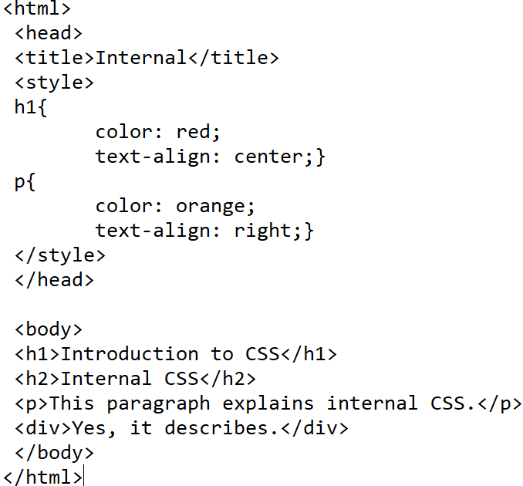

Op a. Internal *

Op b. Inline

Op c. External

Op d. Above code is not valid.

Q2. The __________ of a selector is specified with “#” in CSS.

Op a. ID attribute *

Op b. Class attribute

Op c. Division attribute

Op d. href attribute

Q3. Fill in the blanks of the following code if the name of CSS file is “mystyle.”

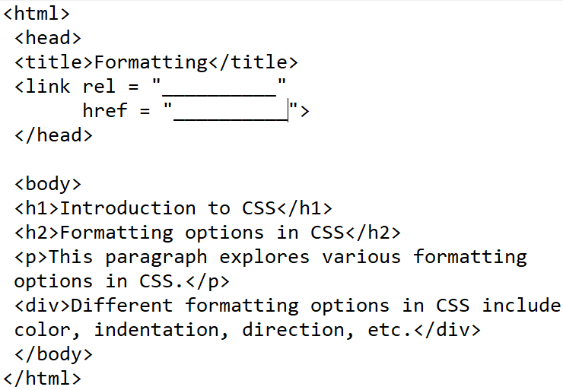

Op a. “stylesheet” and “mystyle.css” respectively *

Op b. “stylesheets” and “mystyle.css” respectively

Op c. “mystyle.css” and “stylesheet” respectively

Op d. “mystyle.css” and “stylesheets” respectively

Q4. Which of the following is an invalid value of color property?

Op a. #a5d8g4 *

Op b. #1a2b3c

Op c. rgb (100, 50, 25)

Op d. rgb (25, 50, 100)

Q5. What can be filled in the blank of the following code?

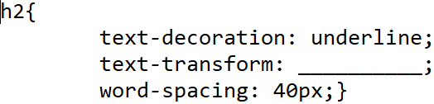

Op a. lowercase, uppercase, or capitalize *

Op b. lower-case, upper-case, or capitalize

Op c. lowercase, uppercase, or capitalized

Op d. lower, upper, or capitalized

Q6. What can be filled in the blank of the following code?

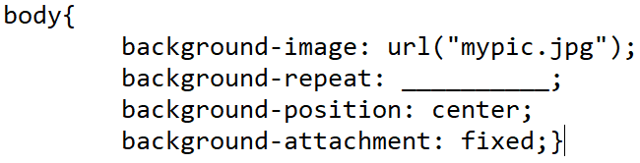

Op a. repeat-x, repeat-y, or no-repeat *

Op b. x-repeat, y-repeat, or no-repeat

Op c. repeat-x, repeat-y, or repeat-no

Op d. repeat-x, repeat-y, or no-repeat-xy

Q7. What is the significance of first appearance of “double” in “p.double{border-style: double;}” as a CSS code?

Op a. It is the class of one of the paragraphs in HTML code. *

Op b. It is the ID of one of the paragraphs in HTML code.

Op c. It is the border of one of the paragraphs in HTML code.

Op d. It is invalid.

Q8. What will happen after the execution of following CSS command?

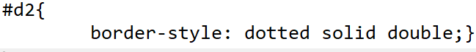

Op a. In the division with ID equal to d2, top border will be dotted, right and left border will be solid, and bottom border will be double. *

Op b. In the division with class equal to d2, top border will be dotted, right and left border will be solid, and bottom border will be double.

Op c. In the division with ID equal to 2, top border will be dotted, right and left border will be solid, and bottom border will be double.

Op d. In the division with ID equal to d2, top border will be dotted, right and left border will be double, and bottom border will be solid.

Q9. What will happen after the execution of following CSS command?



Op a. Top and bottom margins of the paragraphs will be 25px while right and left margins of the paragraphs will be 50px. *

Op b. Right and left margins of the paragraphs will be 25px while top and bottom margins of the paragraphs will be 50px.

Op c. Top margin of the paragraphs will be 25px while right margin of the paragraphs will be 50px.

Op d. Above CSS command is invalid as no class or ID is included.

Q10. What will happen after the execution of following CSS command?



Op a. Left margin of the paragraph with class “ex1” will be same as of its parent. *

Op b. Left margin of the paragraph with class “ex1” will be same as of the body.

Op c. Left margin of the paragraph with ID “ex1” will be same as of its parent.

Op d. Left margin of the paragraph with ID “ex1” will be same as of the division.

Q11. Which of the following is a valid set of tags in HTML tables?

Op a. {<tr>, <th>, <td>, <caption>} *

Op b. {<tr>, <th>, <td>, <tc>}

Op c. {<trow>, <thead>, <tdada>, <tcaption>}

Op d. {<row>, <header>, <data>, <caption>}

Q12. Which of the following code snippet is not correct?

Op a. <th columnspan = “2”>Column2</th> *

Op b. <th colspan = “2”>Column2</th>

Op c. <th colspan = 2>Column</th>

Op d. <th colspan = “2”>Column</th>

Q13. Which command is used to convert the first output into the other?

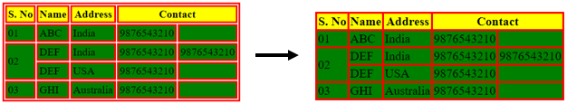

Op a. border-collapse: collapse; *

Op b. border-collapse: collapsed;

Op c. border-collapse: yes;

Op d. border-merge: merged;

Q14. Which of the following commands can place a table at the center?

Op a. margin: auto; *

Op b. padding: auto;

Op c. table-position: center

Op d. table-position: centered

Q15. Select the incorrect statement.

Op a. Table cannot be created without table header tag. *

Op b. Table can be created without table header tag.

Op c. Table data comes under table row.

Op d. Table header comes under table row.

Q16. Choose the correct statement.

Op a. By default, table header text is bold and table data text is normal. *

Op b. By default, table data text is bold and table header text is normal.

Op c. By default, both table header text and table data text are bold.

Op d. By default, both table header text and table data text are normal.

Q17. Which of the following code snippet is incorrect?

Op a. <input type = "radio button">Option</input> *

Op b. <input type = "radio">Option</input>

Op c. <input type = "radio"> </input>

Op d. <input type = "radio ">Gender</input>

Q18. The “for” attribute of label and “id” attribute of input should be equal to __________.

Op a. Bind them together *

Op b. Format them together

Op c. Apply CSS together

Op d. Merge them together

Q19. Which statement is correct in context of the following code?

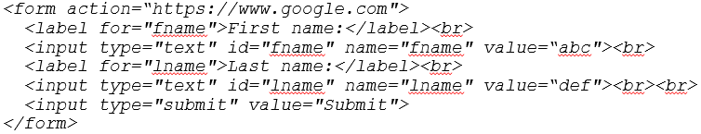

Op a. After clicking on submit button, Google page will open. *

Op b. After clicking on submit button, an error page will open.

Op c. The above code is incorrect as input tag does not include value attribute.

Op d. After clicking on submit button, Google page will open and value attributes will be searched.

Q20. “get” and “post” are the possible values of __________ attribute in the form tag.

Op a. method *

Op b. action

Op c. href

Op c. rel

Q21. Which code will be used to get the given dropdown list?

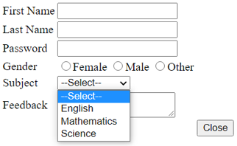

Op a. *

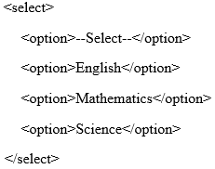

Op b.

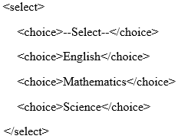

Op c.

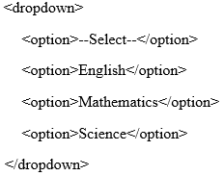

Op d.

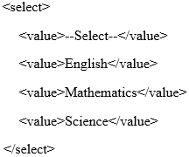

Q22. Which form element gives the customizable dimensions?

Op a. textarea *

Op b. text-area

Op c. radio button

Op d. button

Q23. Which attribute prompts an alert message after clicking a button?

Op a. onclick *

Op b. on-click

Op c. alert

Op d. click-alert

Q24. Which of the following is a valid set of values for justify-content property?

Op a. {space-between, space-around, space-evenly} *

Op b. {space-between, space-around, space-even}

Op c. {spaced-between, spaced-around, spaced-evenly}

Op d. {space between, space around, space evenly}

Q25. Which of the following is a valid set of values for align-content property?

Op a. {start, center, end} *

Op b. {left, center, right}

Op c. {top, center, bottom}

Op d. {start, middle, end}

Q26. Choose the correct statement.

Op a. “justify-content” positions the grid items horizontally while “align-content” does it vertically. *

Op b. “justify-content” positions the grid items vertically while “align-content” does it horizontally.

Op c. “justify-content” positions the grid items across the rows while “align-content” does it across the columns.

Op d. “justify-content” is used for grid container while “align-content” is used for grid items.

Q27. Choose the incorrect grid CSS for the following HTML code.

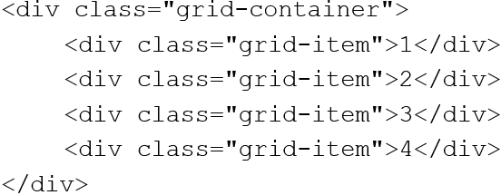

Op a. grid-template-column: auto auto; *

Op b. grid-template-columns: auto auto;

Op c. grid-template-columns: 50px auto;

Op d. grid-template-columns: 100px 100px;

Q28. What will happen after the execution of following CSS command?

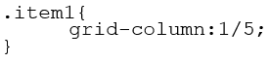

Op a. Grid item whose class is item1 will span across column 1, column 2, column 3, and column 4. *

Op b. Grid item whose ID is item1 will span across column 1, column 2, column 3, and column 4.

Op c. Grid item whose class is item1 will span across column 1, column 2, column 3, column 4, and column 5.

Op d. Grid item whose ID is item1 will span across column 1, column 2, column 3, column 4 and column 5.

Q29. What will happen after the execution of following CSS command?

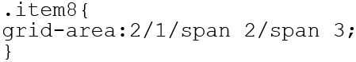

Op a. Grid item whose class is item 8 will be displayed from row 2, column 1 to row 3, column 3. *

Op b. Grid item whose ID is item 8 will be displayed from row 2, column 1 to row 3, column 3.

Op c. Grid item whose class is item 8 will be displayed from row 1, column 2 to row 3, column 3.

Op d. Grid item whose ID is item 8 will be displayed from row 1, column 2 to row 3, column 3.

Q30. Which property in grid container specifies the position of grid items corresponding to their area names?

Op a. grid-template-areas *

Op b. grid-areas

Op c. grid-area

Op d. grid-areas-template

1. Which of the following css pattern is used to change the style of row when the mouse move over that
2. rowtr:over
3. td:over
4. tr:hover
5. td:hover

Ans. C

1. Which of the following is not a pseudo class?
2. Hover
3. focus
4. hyperlink
5. img

Ans D

1. Which of the following is the correct option if we write the following css?

td:hover

{

background-color:yellow;

}

It will change the background color to yellow for

1. the column of the table
2. the column of the table on the mouse over the column
3. the row of the table on the mouse over the row
4. the cell of the table on the mouse over the cell

Ans. D

1. Which of the following is the correct option if we write the following css?

tr:hover

{

background-color:yellow;

}

It will change the background color to yellow for

1. the column of the table
2. the column of the table on the mouse over the column
3. the row of the table on the mouse over the row
4. the cell of the table on the mouse over the cell

Ans. C

1. Which of the following is the correct option if we write the following css?

tr td:hover

{

background-color:yellow;

}

It will change the background color to yellow for

1. the column of the table on the mouse over the cell
2. the row of the table on the mouse over the row
3. the cell of the table on the mouse over the cell
4. It will not apply given style to any row or column

Ans. C

1. Which of the following is the correct option if we write the following css?

td tr:hover

{

background-color:yellow;

}

It will change the background color to yellow for

1. the column of the table on the mouse over the cell
2. the row of the table on the mouse over the row
3. the cell of the table on the mouse over the cell
4. It will not apply the given style to any row or column

Ans. D

1. The elements <DIV> and <SPAN> have the following characteristics

a. Element <DIV> inherits properties defined for <SPAN> in a stylesheet

b. Elements <SPAN> and <DIV> define content to be inline or block-level

c. <DIV> and <SPAN> are used as alternatives for the element <P>

d. <DIV> is used inside element <P>.

ANS: B

2. HTML block-level elements always starts from

a. new line

b. new block

c. same line

d. None

ANS: A

3. Which one from following is a block level element in HTML?

A) <span>

B)<Div>

c)<class>

d) Both A and B

ANS: B

4. Inline elements are normally displayed without starting a new line.

A) True

B) False

ANS: A

5. What is the correct HTML for inserting a background image?

a) <background img:"abc.gif">

b) <body style="background-image:url('abc.jpg')">

c)<body bg="abc.jpg">

d) none

ANS: B

6. The background-repeat: no-repeat; property of CSS is used to

A) Repeat the background image

B) Not to repeat the background image

C) Resize the image

D) None

ANS: B

**If we want define style for an unique element and specific class of element, then which CSS selector will we use?**

A. Class and Id

B. Id and Id

C. Id and Class

D. None of the above

**2. In CSS, Id selector and class selector are defining in side <style> tag with prefix to the name as:**

A. “#” and “.”

B. “.” and “#”

C. “#” and “#”

D. “.” and “.”

**3. Which is the correct syntax for CSS?**

A. Selector {Property ; Value}

B. Selector [Property :Value]

C. Selector {Property : Value};

D. Selector {Property :Value;}

**4. The correct example of class selector is ......**

A. P.xyz{colour:red;}

B. P.xyz{color:red;}

C. P.xyz{colour:red;}

D. P.xyz{color:red};

**5. In CSS, how would you define this image by its id?**

<img> id=”xyz” src=”dog.png”>

1. .xyz{ }
2. #xyz{ }
3. xyz{ }
4. None of the above

**6. The correct example of element selector is ......**

A. .xyz{color:red;}

B. #xyz{color:red;}

C. xyz{color:red;}

D. None of the above

Q1

Which of the following CSS property is used to add shadows to the text?

1. text-shadow
2. text-stroke
3. text-overflow
4. text-decoration

Q2

The CSS property used to set the indentation of the first line in a block of text is -

1. text-indent property
2. text-stroke property
3. text-decoration property
4. text-overflow property

Q3

Which CSS property is used to control the text size of an element ?

A.font-style

B.text-size

C.font-size

D.text-style

Q4

The correct syntax to give a line over text is -

1. text-decoration: line-through
2. text-decoration: none
3. text-decoration: overline

text-decoration: underline

Q5

Which of the following syntax is correct in CSS to make each word of a sentence start with a capital letter?

1. text-style : capital;
2. transform : capitalize;
3. text-transform : capital;
4. text-transform : capitalize;

Q6

Which of the following CSS property is used to specify the space between every letter inside an element?

1. alpha-spacing
2. character-spacing
3. letter-spacing
4. alphabet-spacing

Q1:

<html>

<body>

<form>

select option

<input type="radio" name="c" id="cs">computer

<input type="radio" name="c" id="ce">information technology

<input type="radio" name="c" id="it">civil

</form>

</body>

</html>

Which of the following statement is correct?

1. User can select multiple options
2. User can only select one option
3. Attributes are written incorrect
4. id should be same for selecting one option

Q2

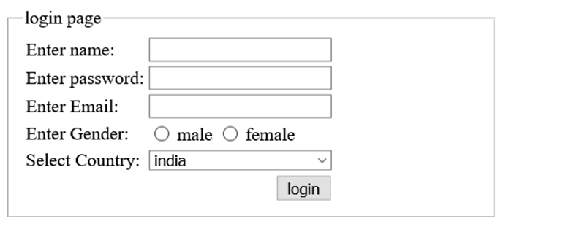

Which of the following tag is used to write “login page” as shown in figure:

1. legend
2. caption
3. fieldgroup
4. assign

Q3 How to create a checkbox in HTML?

1. <input type = "checkbox">
2. <input type = "button">
3. <checkbox>
4. <input type = "check">

Q4

Which of the following tag is used to define options in a drop-down selection list?

1. <select>
2. <list>
3. <dropdown>
4. <option>

Q5

When form data contains sensitive or personal information then which method attribute is more preferable?

1. Get
2. Post
3. Host
4. Put

Q6

Cols attribute in forms text area specifies what?

1. The visible width of a text area
2. The visible number of lines in a text area
3. Size of a text area
4. Size of a text field

Q1 If you only want to style a input type(textbox) in HTML form, you can use which of the following attribute selectors

1. input[type=text]
2. input type=[text]
3. inputtype=text
4. inputtype==text]

Q2 Which property to add space inside the textbox field.

1. Margin
2. Spacing
3. Padding
4. Both margin and spacing

Q3 In order to highlight the border when selection is done to that field, Which of the following selector is used?

a)highlight

b) transit

c)focus

d) border-line

Q4 Which property is used in order to give space outside the textfields in forms?

1. Padding
2. Margin
3. Both margin and padding
4. None

Q6 The CSS property used to make the rounded borders around an element is –

1. border-collapse
2. border-radius
3. border-spacing
4. None of the above

Q7 In order to achieve the desired output ,choose the correct option



a) input{type=text} {  
  border: 2px solid red;  
  border-radius: 4px;  
}

b) input(type=text) {  
  border: 2px solid red;  
  border-radius: 4px;  
}

c)input[type=text] {  
  border: 2px solid red;  
  border-radius: 4px;  
}

d) inputtype:text {  
  border: 2px solid red;  
  border-radius: 4px;  
}

Q1 Which combination of tags is most appropriate for displaying single border, and to set back color to cyan in table.

1. Background-color:cyan; border-collapse:collapse; padding:10px; width:100%;
2. Backgroundcolor:cyan; border:collapse; paddings:10px; height:100%;
3. color:cyan; shrink-border:shrink; padding:10px; width:50%;
4. background-colour:cyan; border:border-collapse; padding:10em; width:100%;

Q2 Which statement is true

1. th,td{text-align:left; padding:20 40 10; border:2px solid red;}
2. table,th,tc{text-align:left; padding:20 40 10; bordre:2px solid red;}
3. tp,td{align:left; padding:20 40 10; border:2px solid red;}
4. tabel,td{text-align:left; padding:20 40 10; border:2pixls solid red;}

Q3 Which statement is true, if you need to set top padding 20px, left padding 10px

1. table,th,td{padding:20px 10px; border-spacing:10px; background-color:#23ab5d;}
2. tabel,th,tr{padding:10px 20px; border-spacing:10px; background-color:#23ab5d;}
3. table,tc,td{padding:20px 10px; borderspacing:10px; background-colour:#23ab5d;}
4. table,ta,td{padding:10px 20px ; border-spacing:10px; background-colour:#23ab5d;}

Q4 For the given table which statement is true

|  |  |  |
| --- | --- | --- |
|  |  |  |
|  |  |  |
|  |  |

1. table,th,td{width:50%; color:white; border-collapse:collapse; }
2. table,th,td{rowspan:2; width:50%; color:white; border-collapse:collapse; }
3. table,th,td{rowspan:2; colspan:1; width:50%; color:white; border-collapse:collapse; }
4. tabel,th,tc{width:50%; color:white; border:collapse; }

Q5 Which answer represents css formatting using id

1. #hellomontu{padding:20px 10px; border-spacing:10px; background-color:#23ab5d;}
2. #hellomontu{paddings:20px 10px; border-spacing:10px; background-colour:#23ab5d;}
3. .hellomontu{padding:20px 10px; border-spacing:10px; background-color:#23ab5d;}
4. hellomontu#{padding:20px 10px; border-spacing:10px; background-color:#23ab5d;}

Q6 Which statement represents alternate colours for table

1. .monkey{background-color:#23ab56;} .zebra{background-color:#45acbd;}
2. .monkey{background-color:#23ap56;} .zebra{background-color:#45acbd;}
3. .monkey{background-colour:#23ab56;} .zebra{background-colour:#45acbk;}
4. #monkey{background-colour:#23ab56;} #zebra{background-colour:#45acbd;}

1. A grid layout consists of

A. Parent element

B. Child elements

C. Both A and B

D. None of the above

Ans: C

2. In-line grid value of display property in grids will give __________view on web browser.

A. Expanded

B. Compressed

C. Centre

D. None of the Above

Ans: B

3. What will be the output of this code snippet?

**.parent { grid-column: 1 / span 2; }**

A. Make "parent" start on column 1 and span 2 columns

B. Make "parent" start on row 1 and span 2 columns

C. Make "parent" start on column 1 and span 2 rows

D. Make "parent" start on row 1 and span 2 rows

Ans: A

4. How many columns will be in grid according to the following code snippet?

**.grid-container { display: grid; grid-template-columns: auto auto auto auto auto auto; }**

A. 4

B. 5

C. 6

D. 7

Ans: C

5. Parent element in grids is called

A. Grid template columns

B. Grid column

C. Grid items

D. Grid container

Ans: D

6. Which property in grids can be used to set grid gap?

A. Grid-row-gap

B. Grid-column-gap

C. Grid-gap

D. Grid-row

Ans: C